Bahria University,

Karachi Campus



COURSE: CEL-221 Computer Architecture And Organization

TERM: FALL 2020, CLASS: BSE- 3 (A)

Submitted By:

_______________________________________________

(ADIL WAHEED) (65190)

Submitted To:

Engr. Muhammed Rehan Baig

Signed Remarks: Score:

INDEX

|  |  |  |  |  |
| --- | --- | --- | --- | --- |
| SNO | DATE | LAB NO | LAB OBJECTIVE | SIGN |
|  |  |  |  |  |
|  |  |  |  |  |
|  |  |  |  |  |
|  |  |  |  |  |
|  |  |  |  |  |
|  |  |  |  |  |
|  |  |  |  |  |
|  |  |  |  |  |
|  |  |  |  |  |
|  |  |  |  |  |
|  |  |  |  |  |
|  |  |  |  |  |
|  |  |  |  |  |
| SNO | DATE | LAB NO | LAB OBJECTIVE | SIGN |
|  |  |  |  |  |
|  |  |  |  |  |
|  |  |  |  |  |
|  |  |  |  |  |
|  |  |  |  |  |
|  |  |  |  |  |
|  |  |  |  |  |
|  |  |  |  |  |
|  |  |  |  |  |
|  |  |  |  |  |
|  |  |  |  |  |
|  |  |  |  |  |

Bahria University,

Karachi Campus



LAB EXPERIMENT NO.

___05____

LIST OF TASKS

|  |  |
| --- | --- |
| TASK NO | OBJECTIVE |
| 1 | Write an assembly program that Read and Print Hello world. |
| 2 | Write an assembly program that add two number within the range of 10. |
| 3 | Write an assembly program that subtract two number within the range of 10. |
|  |  |
|  |  |

Submitted On:

____________

(Date: 30/10/20)

**1.Write an assembly program that Read and Print Hello world.**

**Solution:**

.data

hello:.asciiz "Hello World"

read:.space 20

name:.asciiz "enter any string \n"

.text

la $a0,name

li $v0,4

syscall

li $v0,8

la $a0,read

li $a1,20

syscall

la $a0,hello

li $v0,4

syscall

**Output:**

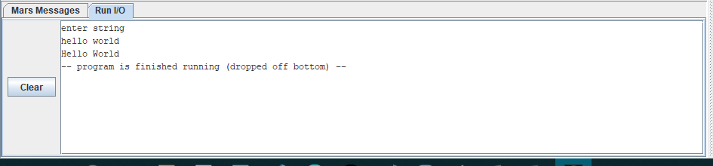

**2.Write an assembly program that add two number within the range of 10.**

**Solution:**

.data

val1: .byte 5

val2: .byte 6

adding:.asciiz "add two number is="

.text

lb $t0, val1

lb $t1, val2

add $t2,$t0,$t1

la $a0,adding

li $v0,4

syscall

li $v0,1

add $a0,$zero,$t2

syscall

**Output:**



**3.Write an assembly program that subtract two number within the range of 10.**

**Solution:**

.data

val1: .byte 7

val2: .byte 6

Subtracting:.asciiz "Subtract of two number is="

.text

lb $t0, val1

lb $t1, val2

sub $t2,$t1,$t0

la $a0,Subtracting

li $v0,4

syscall

li $v0,1

sub $a0,$zero,$t2

syscall

**Output:**

